Kabir Kanha Arora
Rakesh Verma
CSD 330 – Security Analytics
18 April 2020

Detection of Cyber Harassers on Social Media: Progress Report One

This idea is born out of a pressing need to curb a growing problem. Even the best of things come with their pitfalls. Growing technology and connectivity have led to an increased number of child predators and cyber stalkers online. My solution aims to efficiently nip this problem in the bud using advanced Machine Learning techniques such as Support Vector Machines (SVM), Decision Trees, K-Nearest Neighbours and Random Forests.

The use cases for this problem are virtually unlimited. Users on almost all social media websites and discussion forums can fall prey to such predators. This tool will be prototyped on a particular platform and then generalized to suit the requirements of all such platforms, thereby leaving a huge population much safer than they were before. Any website can use this tool to flag suspicious profiles and become a much better space for all its users.
Social media has opened doors for people who misuse it to undermine, harass, humiliate. Threaten and bully others. There is a lack of resources to detect and hinder its occurrence. On average, about 16% students have admitted that they have been bullied at some point in their lives, as per surveys conducted in the United States. The problem is hence indeed grave and needs to be addressed.
The dataset I have used for this project is the one provided at Kaggle, which was part of a contest held 8 years ago. https://www.kaggle.com/c/detecting-insults-in-social-commentary. There is a separate training data set with roughly 4000 tuples and a testing data set with about 2500 tuples.
Each entry contains a date, a comment and a label, where ‘1’ indicates that it is an insult and ‘0’ indicates that it is neutral.
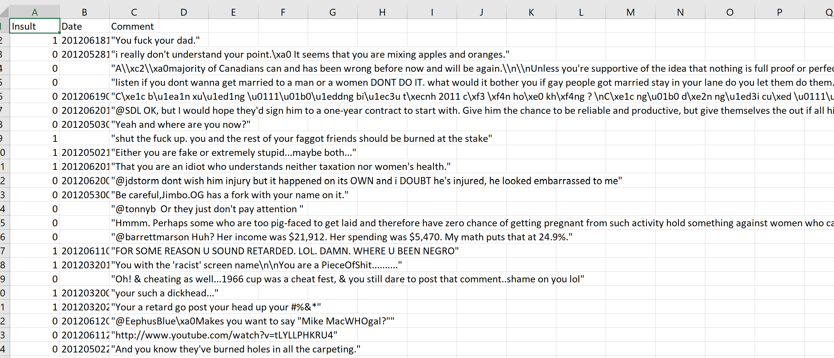
Fig. 1. A snippet of the training data set

The testing data set contains an additional column called ‘Usage’, however it is not relevant to our project at the moment.
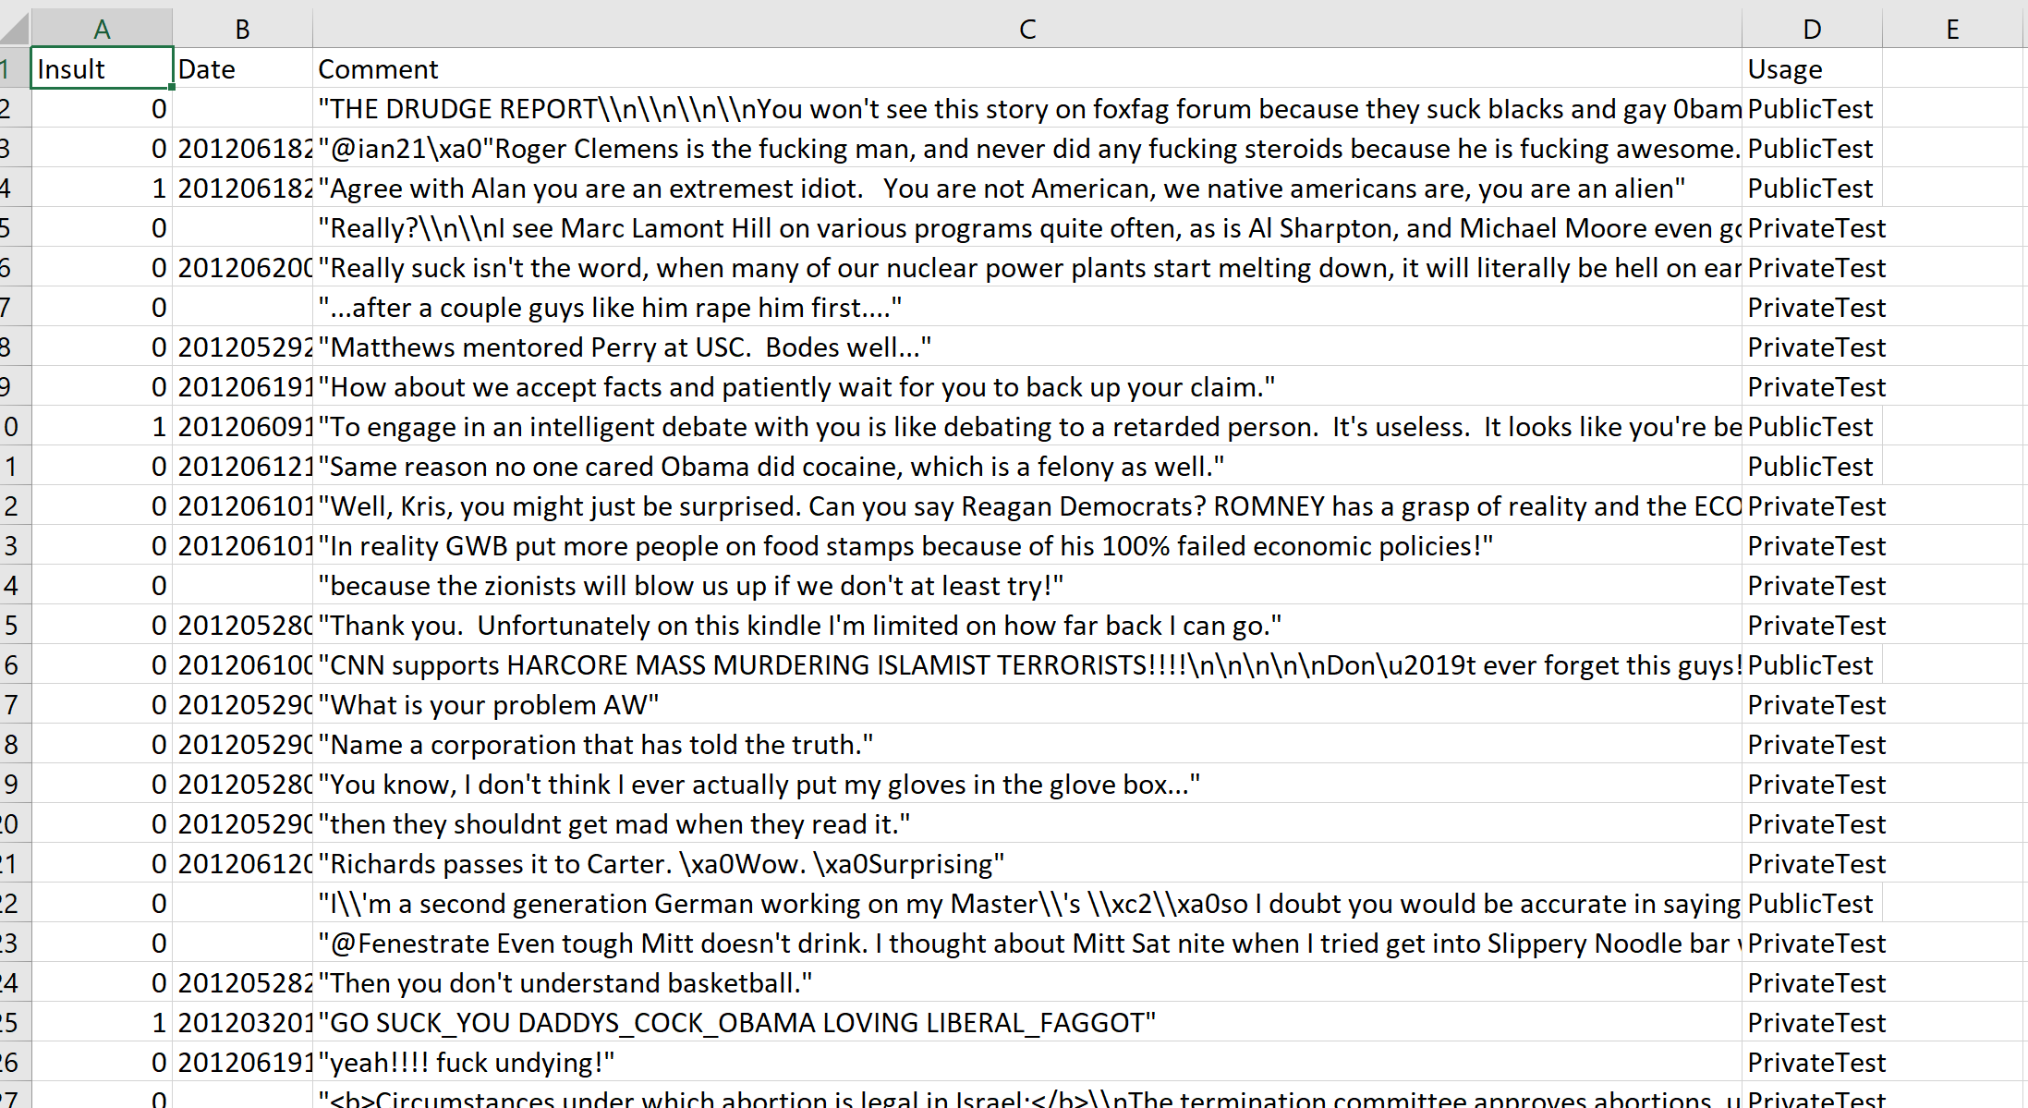
Fig. 2. A snippet of the testing data set
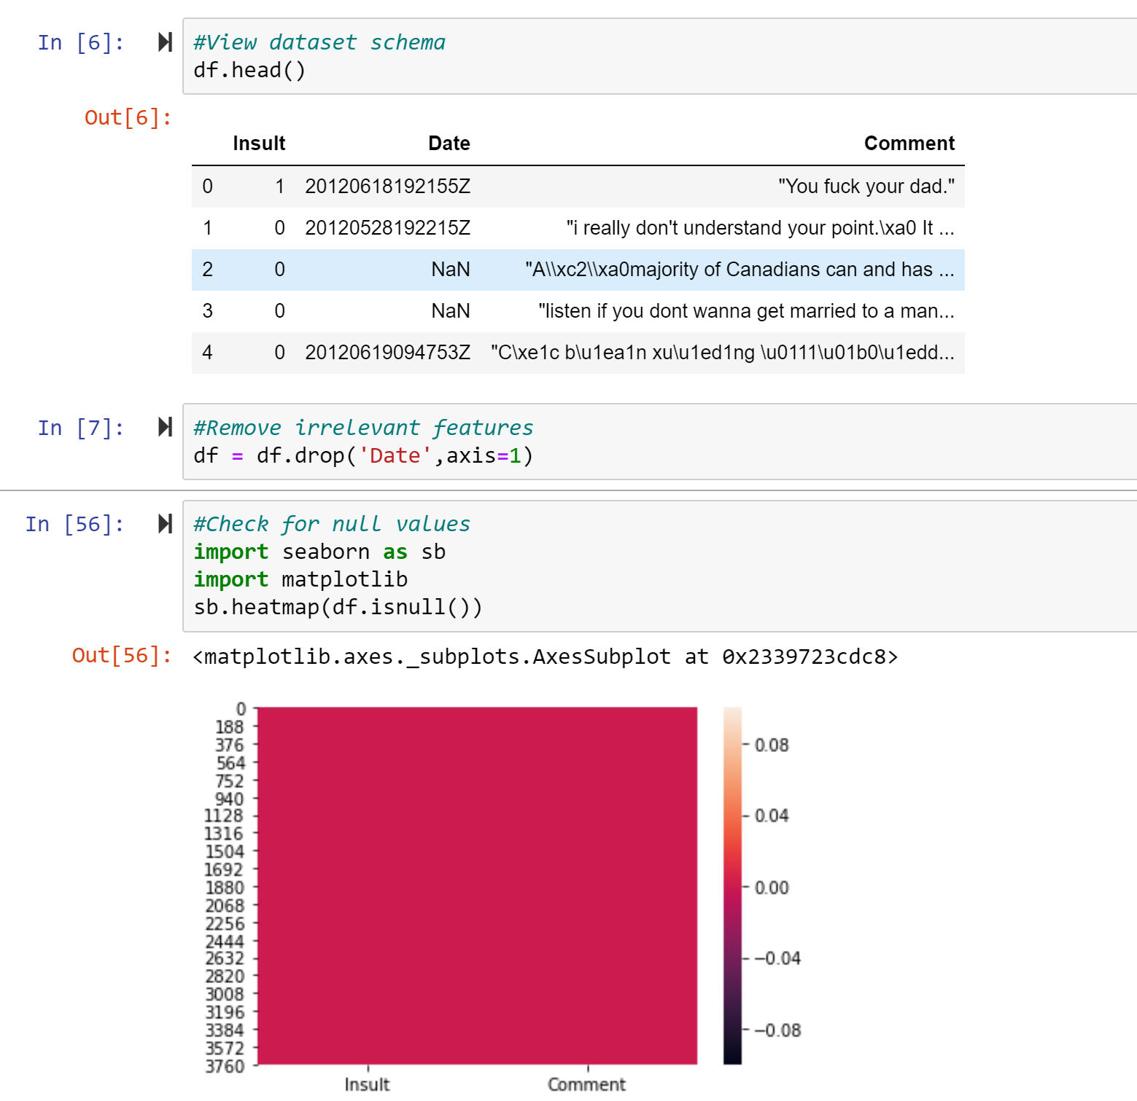
Fig. 3. I remove irrelevant attributes from the training data set and check for duplicates, the same is also done for the testing data set.
Now, since we have just one feature that is to be used to predict the label, I start to build a vocabulary, using somewhat a bag of words approach. It is important to note here that this data set is off a website that has casual chats and hence, there are typos galore, The data is pretty dirty and preprocessing and cleaning takes up a major chunk of the effort.
I saw a large number of words with front slashes and backslashes like \xe2, which are probably escape sequences and have a special meaning, so to remove them, as they are garbage to us, I create a regular expression of the form:
slash_all = r'\s*(?:[\w_]*[/\\](?:[\w_]*[/\\])*[\w_]*)'
Which is then followed by:
comment = re.sub(slash_all,' ',comment)
I also remove all special characters except the apostrophe (‘), trim extra whitespace and change every character to lower case. I then tokenise and remove stop words. After this, stemming is done as the last stage. Collectively, these steps work to reduce the size of the vocabulary and prevent it from blowing up.
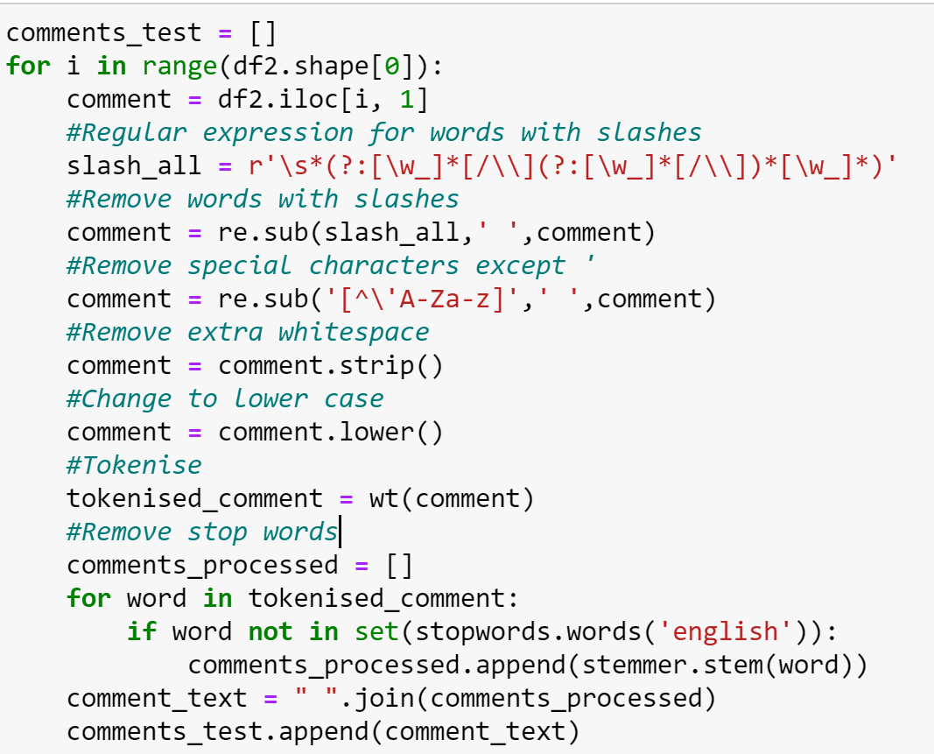
Fig. 4. The word manipulation code
Then, the feature matrix is created, and the training and testing data sets are transformed.
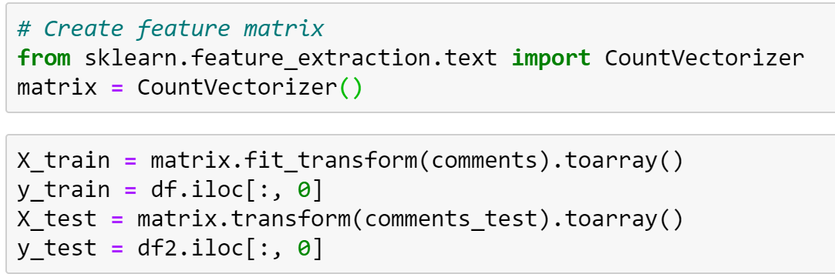
Fig. 5. The set-up
Once the data is ready to go, I run it through three classifiers – Naïve Bayes, Decision Trees and Suppurt Vector Classifiers. The results of all three, in order, are shown below.
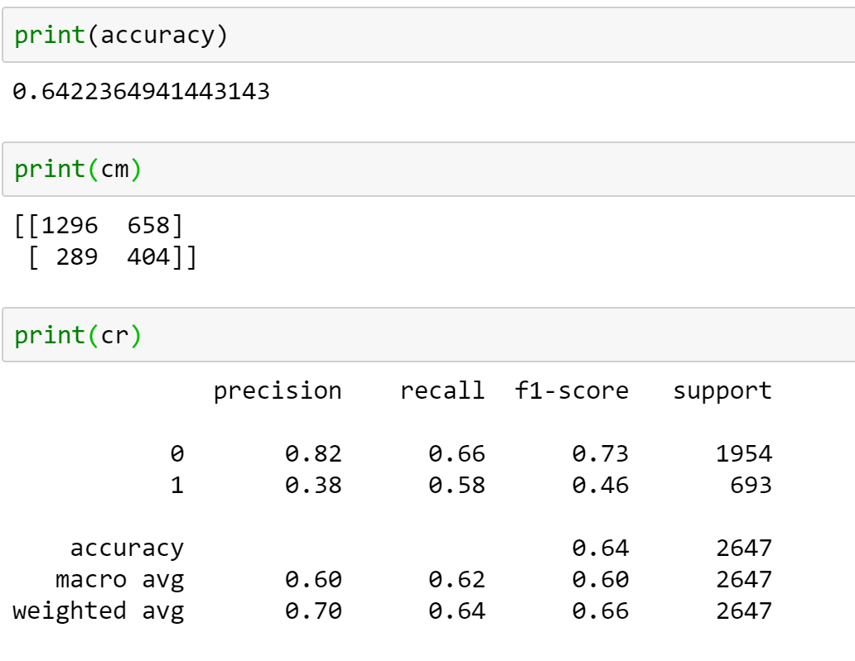
Fig. 6. The accuracy, confusion matrix and classification report for the Naïve Bayes classifier
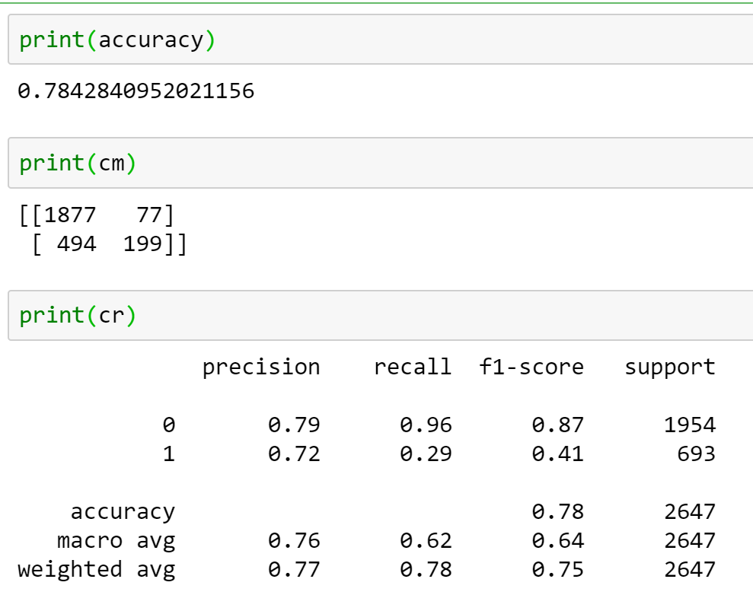
Fig. 7. The accuracy, confusion matrix and classification report for the Decision Tree classifier
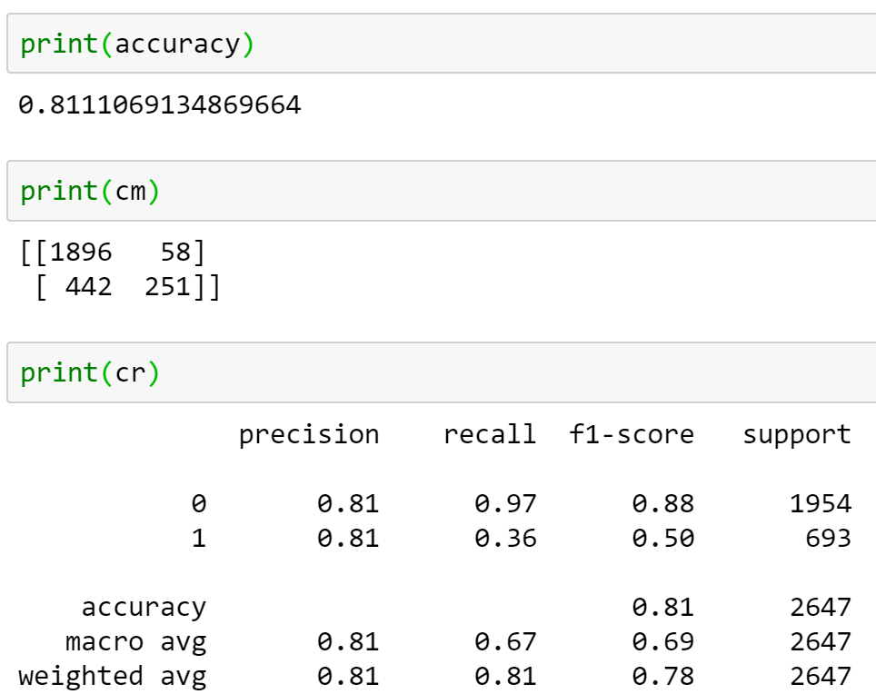
Fig. 8. The accuracy, confusion matrix and classification report for the Support Vector classifier

Clearly, SVC gives the best results and an accuracy of 81% is pretty good. It is followed by Decision Tree and then by Naïve Bayes, which does not give a good result. This research can also be expanded to other datasets available on the internet, such as BayzickBullyingData, TextMiningAndCyberCrimeData, Formspring Data. I am also keen to use the random forest classifier on this as well as clustering. The Wikipedia list of bad words could also be added to the vocabulary to enhance the classification and we could also include TF-IDF to get a better result.

Works Cited
Samghabadi, Niloofar Safi, et al. "Detecting nastiness in social media." Proceedings of the First Workshop on Abusive Language Online. 2017.
Escalante, Hugo Jair, et al. "Sexual predator detection in chats with chained classifiers." Proceedings of the 4th Workshop on Computational Approaches to Subjectivity, Sentiment and Social Media Analysis. 2013.
Miah, Md Waliur Rahman, John Yearwood, and Sid Kulkarni. "Detection of child exploiting chats from a mixed chat dataset as a text classification task." Proceedings of the Australasian Language Technology Association Workshop 2011. 2011.
Huang, Qianjia, Vivek Kumar Singh, and Pradeep Kumar Atrey. "Cyber bullying detection using social and textual analysis." Proceedings of the 3rd International Workshop on Socially-Aware Multimedia. 2014.
Nandhini, B. Sri, and J. I. Sheeba. "Online social network bullying detection using intelligence techniques." Procedia Computer Science 45 (2015): 485-492.
Xu, Jun-Ming, et al. "Learning from bullying traces in social media." Proceedings of the 2012 conference of the North American chapter of the association for computational linguistics: Human language technologies. Association for Computational Linguistics, 2012.

References
- Stack Over Flow
- Github
- Free Code Camp
- Machine Learning Mastery
- StatQuest
- Towards Data Science
- Geeks for Geeks

